**Week 3**

**Aim:** Find a samples space for tossing two coin with replacement, assign random variable for the sample space, plot pmf and CDF.

**Code:**

S = tosscoin(2,makespace=TRUE)

Y=c(0,1,2)

plot(Y)

prob=c(0.25,0.5,0.25)

plot(Y,prob,type="h",xlab="Y",ylab="PMF",ylim=c(0,1))

abline(h=0)

cdf=c(0,cumsum(prob))

cdf.plot=stepfun(Y,cdf)

plot.stepfun(cdf.plot,xlab="Y",ylab="CDF",do.points = TRUE)

plot.stepfun(cdf.plot,xlab="Y",ylab="CDF",verticals=FALSE,do.points = TRUE)

Output:

> S = tosscoin(2,makespace=TRUE)

> Y=c(0,1,2)

> plot(Y)

> prob=c(0.25,0.5,0.25)

> plot(Y,prob,type="h",xlab="Y",ylab="PMF",ylim=c(0,1))

> abline(h=0)

>

> cdf=c(0,cumsum(prob))

> cdf.plot=stepfun(Y,cdf)

> plot.stepfun(cdf.plot,xlab="Y",ylab="CDF",do.points = TRUE)

> plot.stepfun(cdf.plot,xlab="Y",ylab="CDF",verticals=FALSE,do.points = TRUE)

**Graph:**

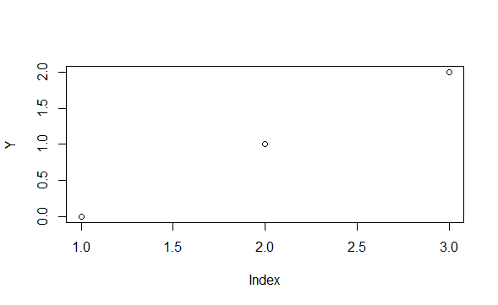

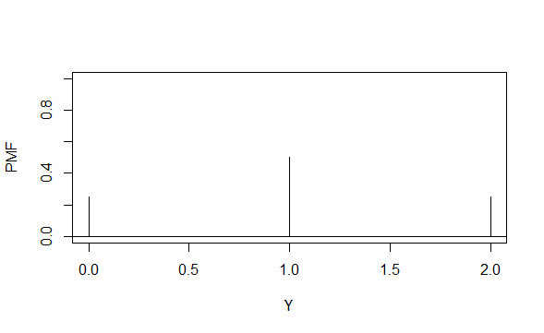

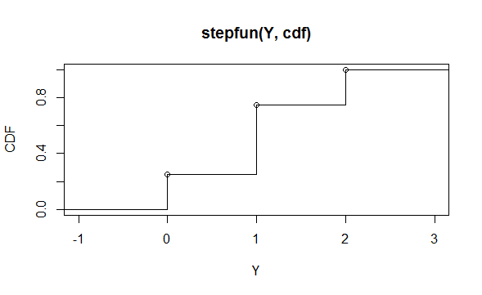

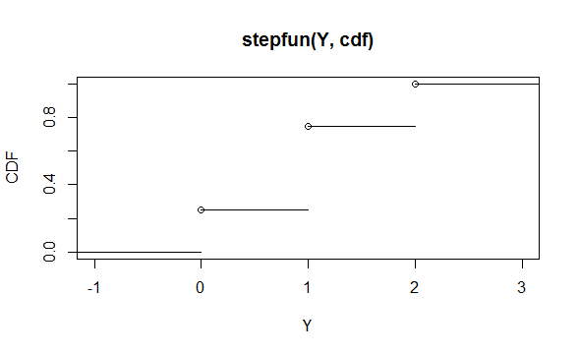

Result

The Pmf and the cdf of the distribution involving the tossing of two coins was successfully implemented.